Algebra 3-4 Name: ____________________

1.6 Worksheet Block: ________

For problems 1 – 10, solve the absolute value problem. For the inequalities, graph your answers on a number line.

1. 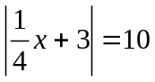 2. 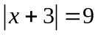

3. 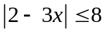 4. 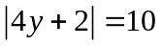

5. 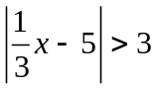 6. 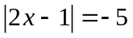

7. 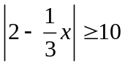 8. 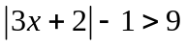

9. 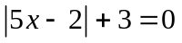 10. 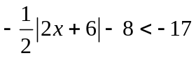

For problems 11 – 18, graph the absolute value equation.

11. 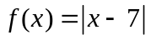 12. 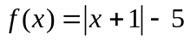
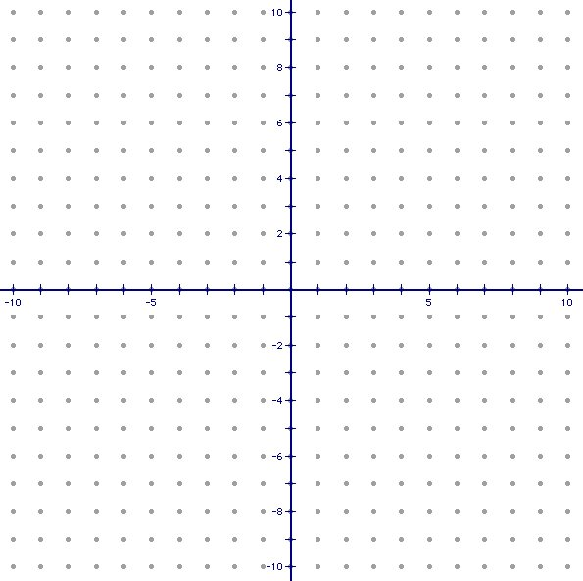

13. 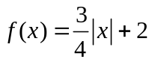 14. 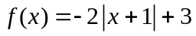

15. 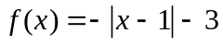 16. 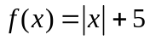

17. 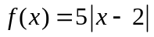 18. 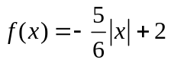

For problems 19 – 22, write the equation of the graph.

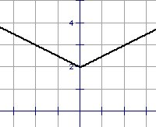
19. 20.
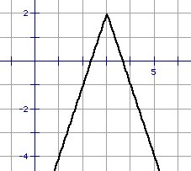

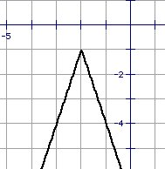
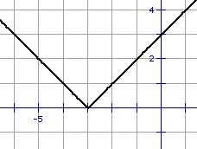
21. 22.

For problems 23 – 26, use the following information to answer the questions.

23. On average an elephant will live from 30 to 40 years. Write an absolute value inequality that represents the typical ages of an elephant.

24. Most fish can adjust to a change in the water temperature of up to 15°F if the change is not sudden. Suppose a lake trout is living comfortably in water that is 58°F. Write an absolute value inequality that represents the range of temperatures at which the lake trout can survive.

25. In industrial technology class, you must cut a piece of wood within 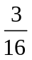 inch of the teacher’s specification of 5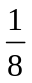 inches. Write an absolute value equation that describes the acceptable lengths for this piece of wood.

26. The average price for a music CD is $15.50. Depending on where you shop, the price may vary as much as $3.00. Write an absolute value equation describing the possible prices of music CD’s.

